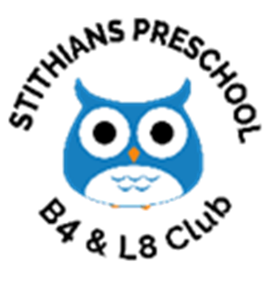

**Stithians Pre-School, Church Road, Stithians, Cornwall TR3 7DH**

**general_enquiries@stithianspreschool.org.uk**

**Tel: 01209 862727**

**Charity Registration No. 1032443**

**Ofsted reference: 102875**

Stithians Pre-school

B4 & L8 Club

Welcome Pack



**Welcome to Stithians Pre-School, B4 & L8 Club**

**Thank you for your interest in Stithians preschool B4 & L8 Club. Please find enclosed Preschool information and registration forms for you to complete should you wish to apply for a place for your child for Preschool, B4 & L8 Club.**

**Admissions**

Our Preschool B4 & L8 Club is open to all children and families from all sectors of the community, regardless of gender, race, language, culture, disability or learning difficulties.

**About Us**

We would like to warmly welcome you and your child to Stithians Pre-school B4 & L8 Club.

We hope that you will find the information in this pack useful to you. Our Pre-School B4 & L8 Club is in a rural setting in the centre of Stithians village within in a purpose-built preschool attached to the Stithians Centre. We are a registered charity run by a voluntary committee made up of parents and members of the community. We understand every child is unique and offer a fun, play based learning environment aimed at enabling each child to learn and develop at their own pace and to the best of their potential. We are child led and encourage and promote autonomy and independence.

We are registered with Ofsted to provide care and education for children between 2-5 years within the preschool, and 2-11 years old at our B4 and L8 Club. In our last inspection we retained our ‘GOOD’ rating.

We provide education and care for children in the preschool from the age of two up to school age. You may be eligible for funding for up to 30 hours a week once your child has turned two.

**If you have any questions, please do not hesitate to contact a member of staff.**

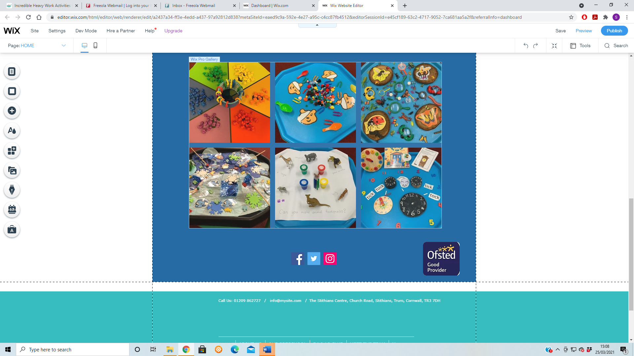**Please go to www.childcare.gov.uk to find out if you are eligible for help with childcare costs.**

**Our Pre-School Setting**

**Session Times**

**Morning Session: 9am -12pm**

**Afternoon Session: 11am – 2pm (includes lunchtime)**

**Full Day Session: 9am- 2pm (includes lunchtime)**

**2.30pm finish for children with siblings who attend school**

**B4 Club: 8am-school opening time**

**L8 Club: school finish-6pm (2.30- 6pm for Preschool children)**

**Children are collected at the end of the school and taken to the Preschool building for L8 Club.**

***We do our best to be flexible with session times between 8am-6pm to suit you and your child.***

***Please speak to a member of staff to enquire about availability.***

***Our session charges are as follows:***

***Pre-school sessions***

***2 year olds - £6.50 per hour***

***3-4 year olds- £5.30 per hour***

***B4 & L8 Club sessions***

***B4 Club - £5.60 (includes breakfast)***

***L8 Club sessions- £5.60 per hour (includes a snack)***

***\*We offer a 10% sibling discount on all fees\****

***Siblings who attend the same session will receive a 10 % discount***

**Meet The Team**

***Linsey Matthews- Manager***

I have worked at Stithians Preschool for several years now in a variety of roles. Initially, I was a parent and committee member and then took on the role of Early years practitioner. Since September 2018 have been Deputy Manager and Special educational Needs Coordinator. I have completed my Level 3 in Childcare and various courses related to Special Educational Needs. I live with my Husband Stu and our Four children Dylan, Emily, Louie and Sophia. I enjoy going out to eat and walks and spending time with friends and family.

***Nicki Halstead- Deputy Manager***

I have worked with children in Early years for over 20 years as an EYFS teacher. I have a BA (hons) degree in PE and Social Science and went on to study for a PGCE in Primary education. I moved to Cornwall over a year ago from West Yorkshire and love living down here. In my spare time I enjoy paddle boarding, swimming, surfing and walking the dogs on the beach.

***Joanne Pymer- Business Manager***

I have worked with children in Early years and primary schools for many years both in the UK and abroad in Bahrain. Through my roles I have gained a great deal of experience and completed my BA Honours Degree in Early Years and Education. I live in Helston with my partner Lee and our children Michael, Chris, Isaac and Millie and our dog called Rookie. In my spare time I love to go for walks, exploring the local beaches, cooking, watching films and love listening to music.

***Alana King – Preschool Practitioner***

***Edwina (Edie) Holley – Preschool Practitioner***

***Bev Hickson – Preschool Practitioner***

**Settling In and your Child’s First day**

Every child who is offered a place at Stithians Pre-School is invited to join in a taster session before their child officially starts. This is an opportunity for you and your child parent to become familiar with the preschool environment, routines, staff team and meet other children who they will be joining.

On your child’s first day, you will be greeted by the Supervisor and your child’s Key Person. Your child will have their own assigned name peg. Please help your child to hang up their coat and bag on their designated peg and guide them to our name board in the main room where they will look for their names and place them on the board to let us know that they are in preschool.

As our session starts from 9 am you will need to stay within your pod and be responsible for your child up until this time. If your child is finding their new experience of starting preschool stressful, please inform a member of staff who will be happy to help with settling. This is not uncommon and can be a new experience for both you and your child.

**Key Person**

At Stithians Pre-School each child is assigned a key person when they join our setting. This member of staff will act as your key point of contact and will work with you and your child to create your child’s online learning journey and recording their progress over time using observations, photos and your child’s work.

We greatly value the strong, positive relationships we build with the children and their families. We believe that children settle best when they have a key person to relate to, who knows them and their parents/carers well. We believe that your child will feel settled at the preschool when they have formed a good relationship with their key person. We encourage parents/carers participation and love to hear about your child’s experiences and achievements at home.

We use the online learning journey ‘Tapestry’ to share your child’s learning and development.

When your child starts with us we will ask you to provide your email address which we will use to set up your account. You are able to add family members so that they can also share in your child’s learning.

**Dropping off and Picking up your child**

During Pre-School hours the responsibility for your child's safety lies with the staff. Under the terms of our insurance, that responsibility must be transferred at the end of each session to a responsible adult, aged 18 or above, who is known to the staff. Therefore, could you please ensure that the staff know if anyone other than yourself is going to collect your child, e.g., friend, grandparent, and that it is an adult that comes to collect your child. WE CANNOT hand over responsibility of your child to anyone under 18 years of age or who we have not been notified will be collecting them. ***We will ask you to create a password which you can share with the individual collecting your child.***

We ask all parents to make sure that they are prompt in collecting their children. If you are going to be late to collect your child, please contact preschool as soon as possible and inform us of the delay.

**What to bring to Preschool**

We want the children to get the most from all the activities available, which include messy play and outdoor play in all weathers! We would ask that you send your child in clothes that you do not mind getting muddy/messy, and with a spare change of clothes in their bag.

**We also suggest the following:**

* **Bag/rucksack**
* **Coat/ waterproofs**
* **Nappies and wipes if required.**
* **Hat/Sun Cream (Summer term)**
* **Wellies (rainy days)**
* **A water bottle**

Could all item that are brought in be **clearly labelled** with your child’s name. We cannot be responsible for items that are lost or damaged.

**Snack time and lunch sessions**

We ask parents/carers to contribute towards our snack by providing a piece of fruit, vegetable sticks, breadsticks, cheese, or rice cakes for each session they attend. This can be handed to a member of staff by your child on arrival or placed in your child’s bag. These items will then be shared out at snack time with all the children to encourage children to learn social skills, to try new foods, make healthy eating choices. Your child will also be offered a drink of milk or water.

Children attending between 12-1pm, over the lunch time session are asked to bring in a healthy lunch box, in a labelled bag. If you would like ideas for your child’s lunchbox, please speak to a member of staff.

Could we ask that you cut all small foods in half as they can be a choking hazard. These are foods like grapes, blueberries and cherry tomatoes. Please also provide a named water bottle for your child.

**Absences**

Please ring or email Preschool if you know your child is going to absent. The contact details are Tel: 01209 862727 and Email: general_enquiries@stithianspreschool.org.uk.

If you are planning a holiday during term time, please inform a member of staff in writing if you are of the dates your child will be absent from Preschool.

**If your child is unwell**

If your child is ill, then we advise parents to keep them off preschool until they are feeling better. If your child becomes ill whilst in our care, we will contact parents and ask you to collect your child as soon as possible.

**It is our policy that any child who has sickness or diarrhoea must be kept away from preschool for 48 hours after their last bout.**

**We look forward to welcoming you and your child/children to Preschool and if you have any further questions or queries then please do not hesitate to get in touch or speak to a member of staff.**

Many Thanks,

**The Stithians Preschool, B4 & L8 Team**

